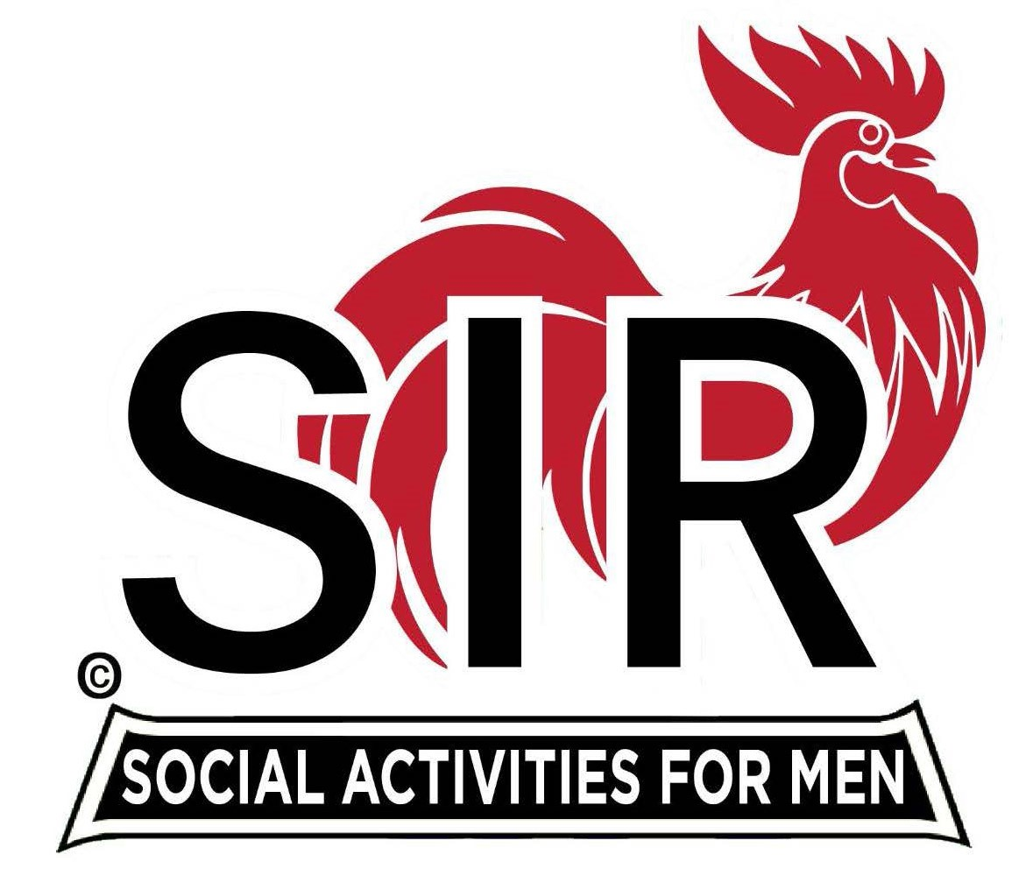
Las Trampas Branch 116
BEC Meeting Agenda
June 19, 2023, 9:15 AM at Boundary Oak

The Mission of SIR is to enhance the lives of our members through fun activities, events and luncheons while making friends for life.

9:15 am Call to order; Secretary, Paul Ramacciotti – Confirm quorum and
Approval of April 17, 2023 BEC meeting minutes

9:20 am Standing Reports

- Treasurer – Jeff Johnson, Al Satake, Charlie Guthrie

- Luncheon Report – Michael Schneider

- June 19 Boundary Estimated Count

- Membership – Phil Goff

4. RAMP Department Head Reports:

- Recruitment – Don Schroeder
- Activity Coordinator – Mike Ward
- Member Relations - Michael Barrington
- Publicity – Paul Russell

9:40 am Little SIR Updates – Alan Pope

- Speaker Info – John Doolittle
- Birthday Boys – May and June

9:50 am Updates & New Business

- Recruiting: Farmer’s Market Booth, Sandwich Board - Golf
- Bank Change
- Lunch Subsidy
- Lunch Seating
- Memorial
- Holiday Party

10:15 am Adjourn: Lunch

